Because I have been given much
I too must give
Because of thy great bounty Lord
Each day I live
I shall divide my gifts from thee
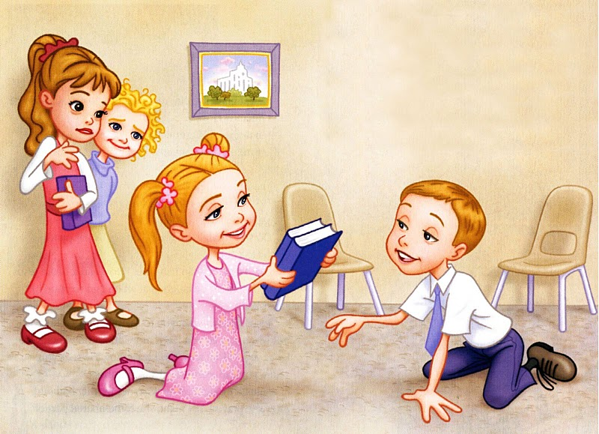
With every brother that I see
Who has the need of help from me

Because I have been sheltered fed
By thy good care
I cannot see another’s lack
And I not share
My glowing fire my loaf of bread
My roof's safe shelter overhead
That he too may be comforted
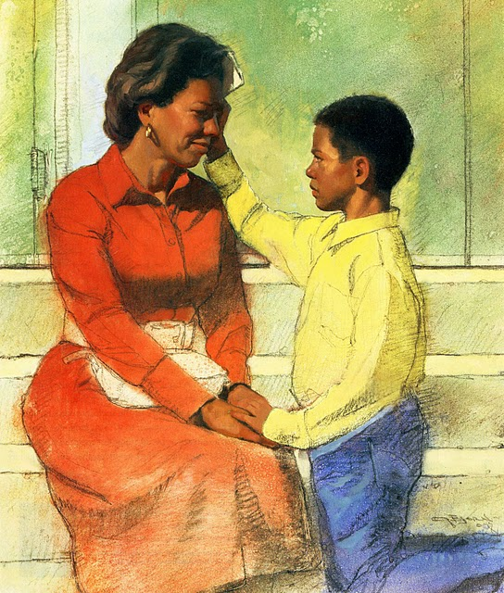
Because I have been blessed
By thy great love dear Lord
I’ll share thy love again
According to thy word
I shall give love to those in need
I’ll show that love by word and deed
Thus shall my thanks
Be thanks in deed

