Fair is the sunshine
Fairer the moonlight
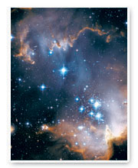
And all the stars in heav’n above
Jesus shines brighter
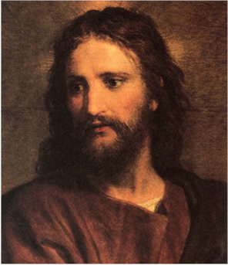
Jesus shines purer
And brings to all the world his love
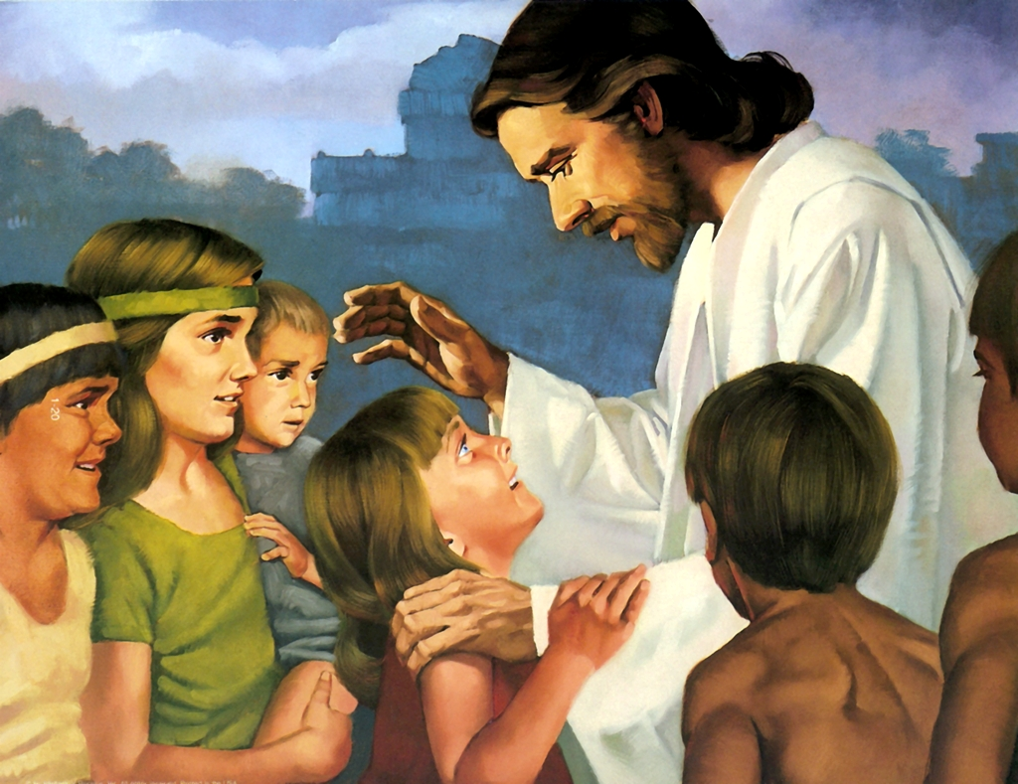

Fair are the meadows,
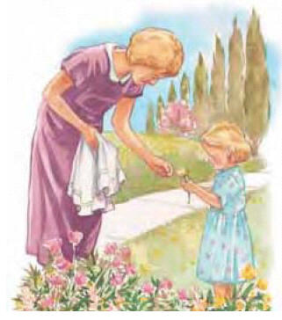
Fairer the woodlands,
Robed in the flowers of blooming spring
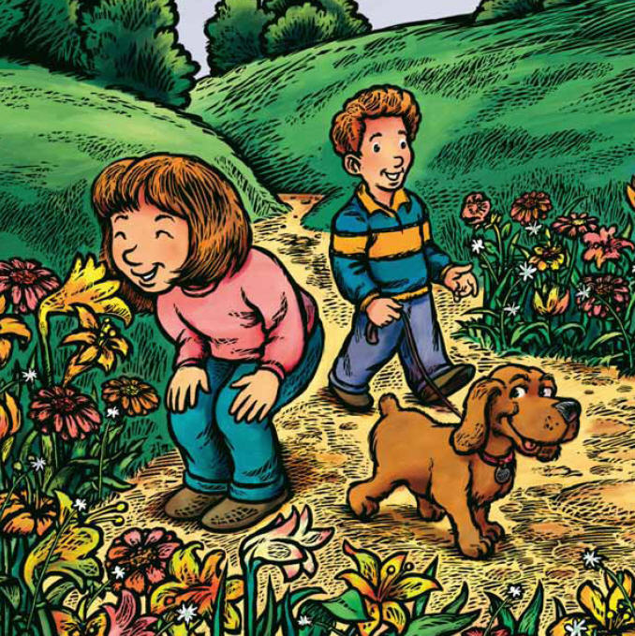
Jesus is fairer,
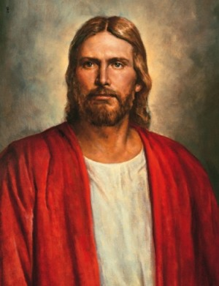
Jesus is purer.
He makes the sorrowing spirit sing
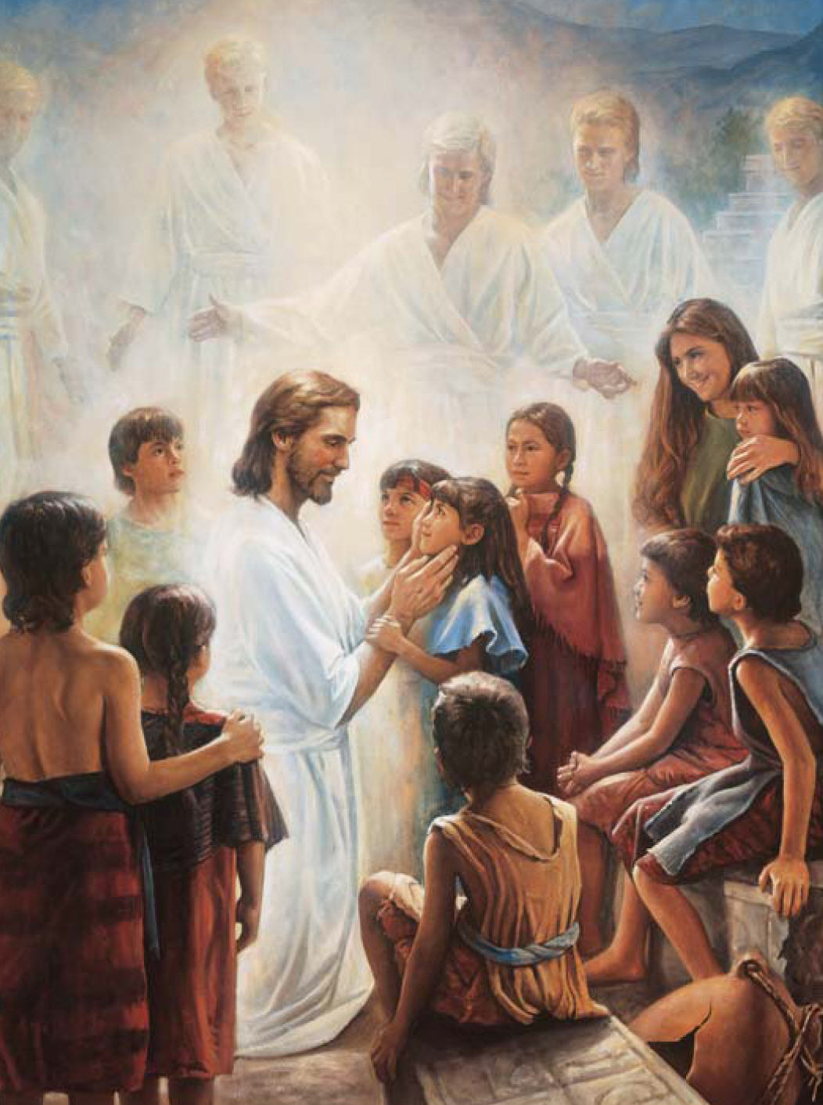
Beautiful Savior!

Lord of the nations!
Son of God and Son of man!
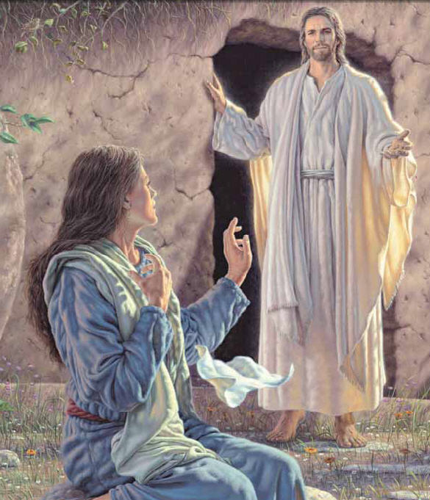
Thee will I honor, praise, and give glory,
Give praise and glory ever more!
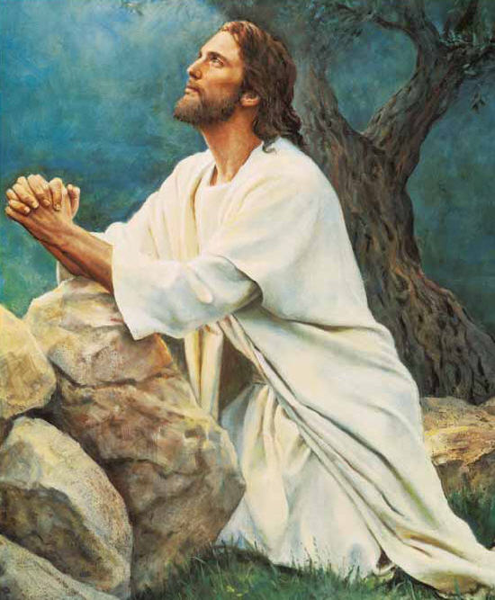
Evermore!

