Baby in a manger
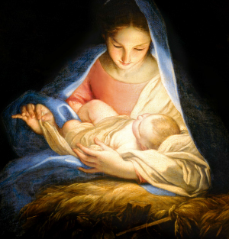
‘Ere the break of day
Baby in a manger
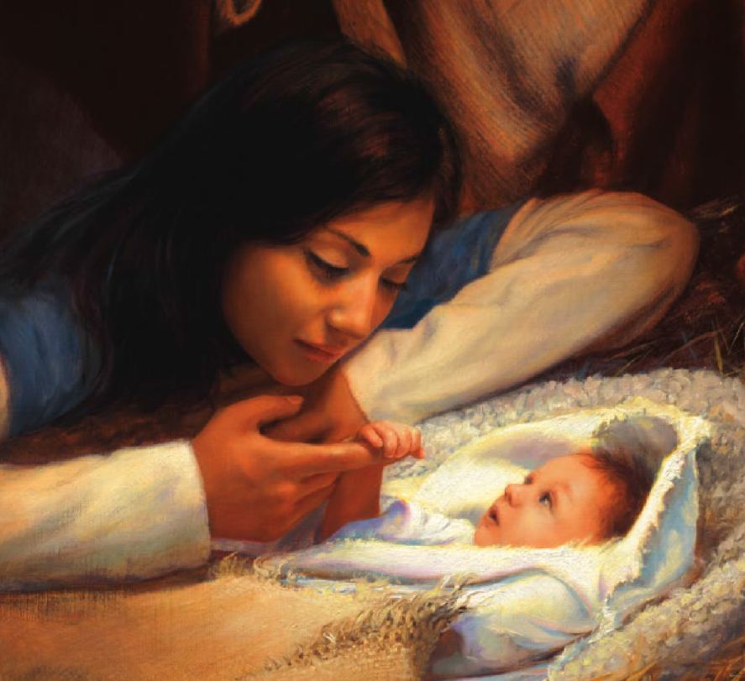
Sleeping on the hay
Hear the angels singing
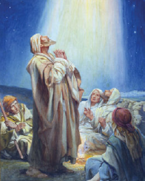
Joyful at thy birth
“Gloria! Gloria!

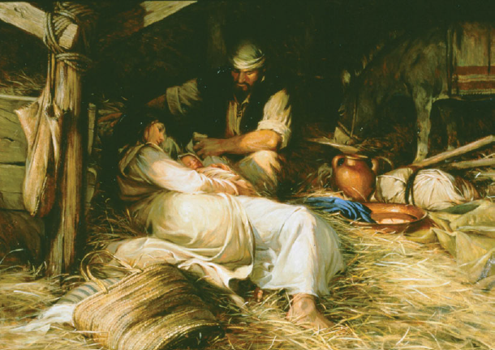

Peace on earth”
Baby in a manger
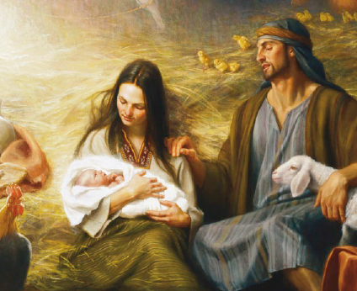
Legions gather nigh
Heaven’s song
re-echoes
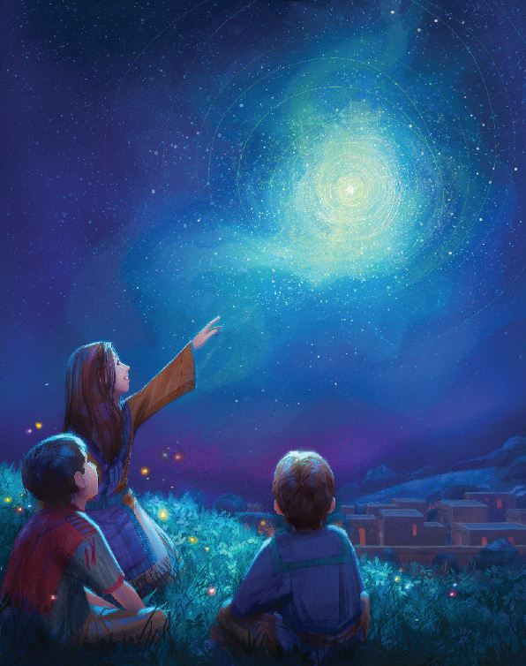
‘neath the starry sky
Hear the angels singing
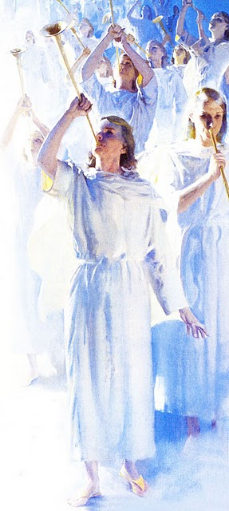
joyful at thy birth
“Gloria! Gloria!
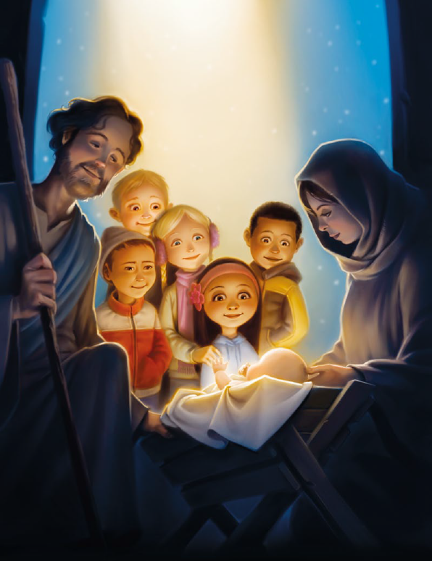
Peace on earth”
Baby in a manger
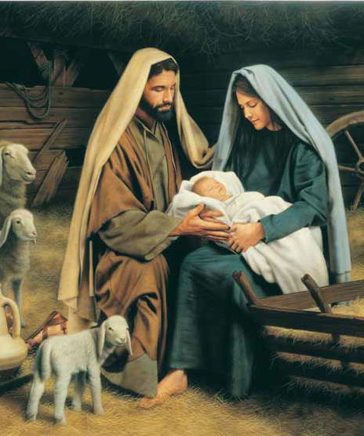
heaven’s host proclaims
“This is the Messiah!
Jesus is His name”
Hear the angels singing
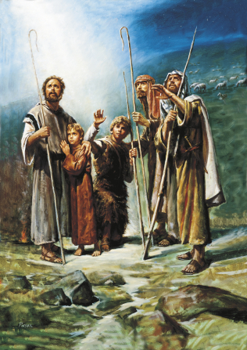
joyful at thy birth
“Gloria! Gloria!
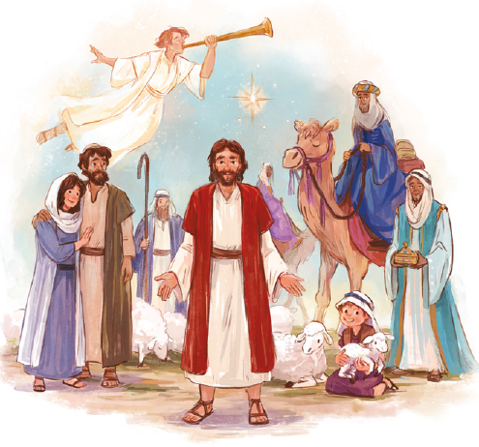
Peace on earth”

