On the Bethlehem hillside
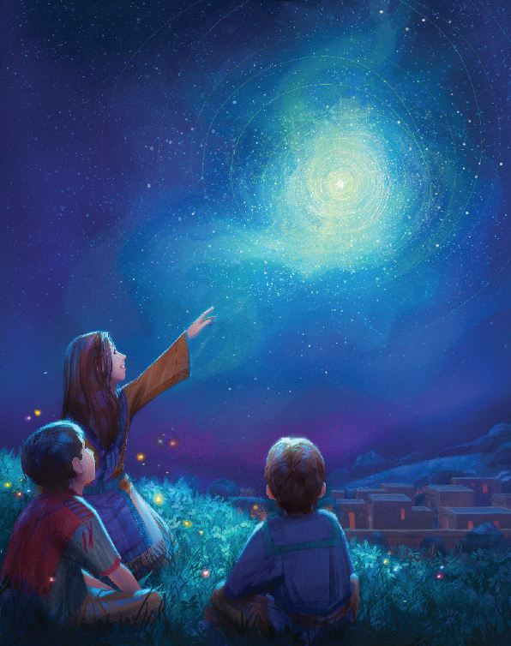
The shepherds at night
Beheld choirs of Angels
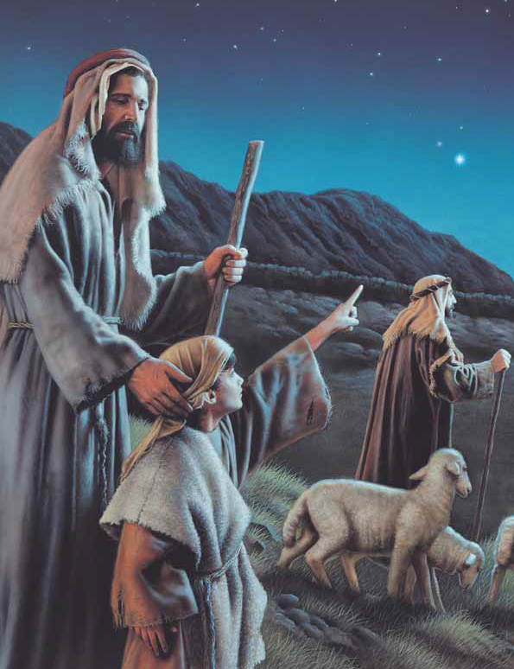
In glory so bright
Sing of the Christ child
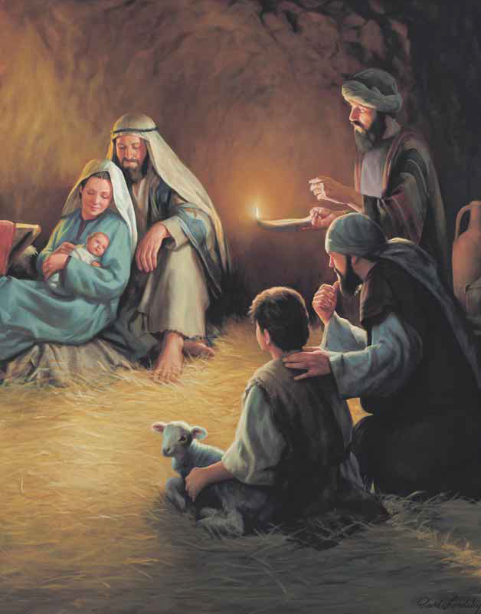
Born of royal line
Come see the baby
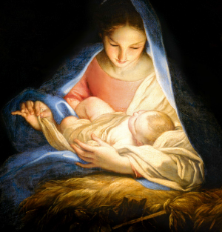
The Baby Divine!
Sing Gloria Gloria
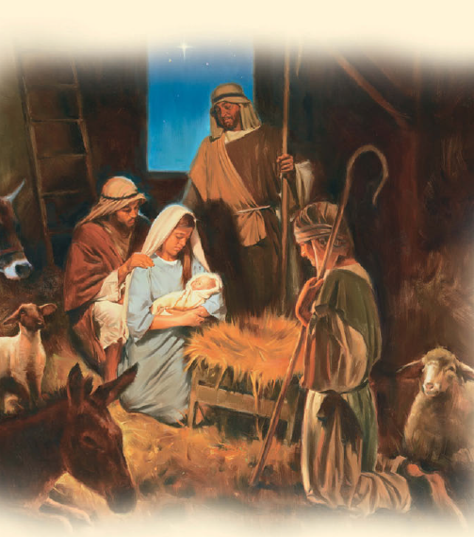
Born the promised One
Sing Gloria Gloria
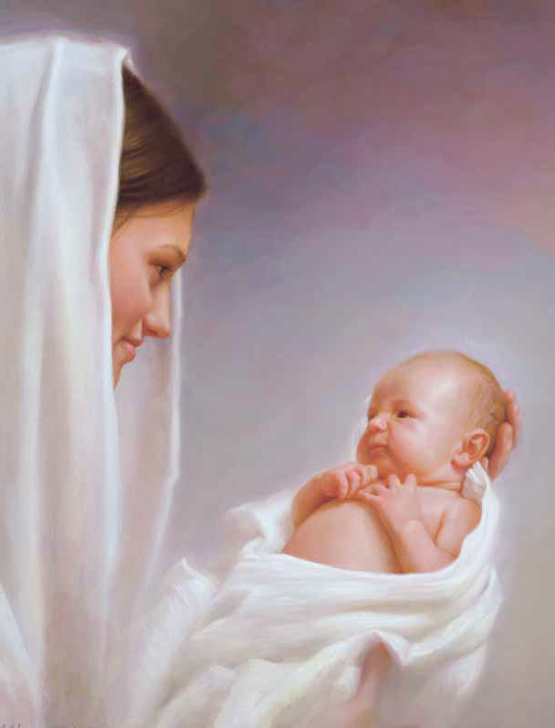
Glory to the Son!
The shepherds ran quickly
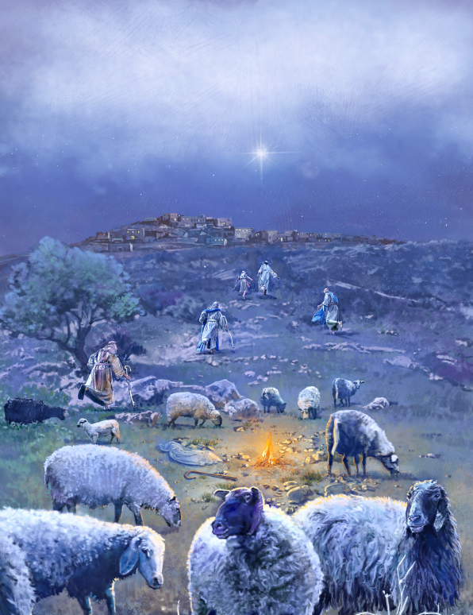
In search of the One
And there in the manger
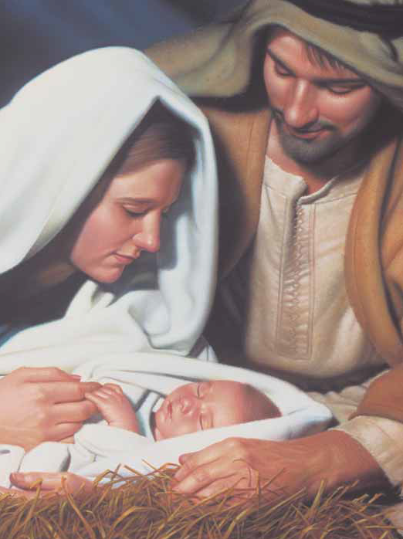
Lay God’s promised son
Sing of the Christ child
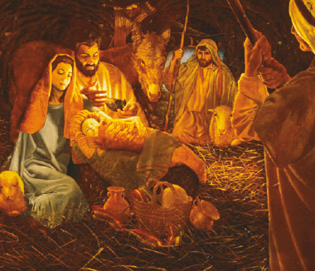
Born of royal line
Come see the baby
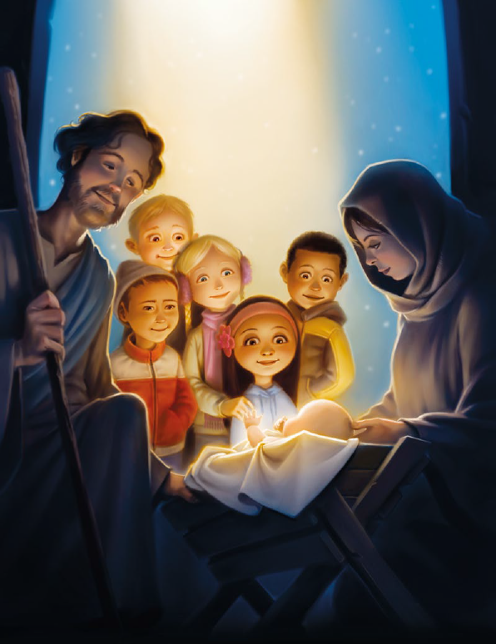
The Baby Divine!
Sing Gloria Gloria
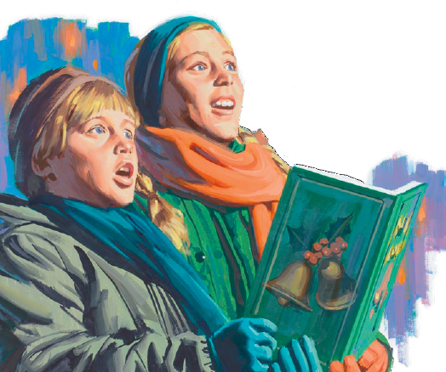
Born the promised One
Sing Gloria Gloria
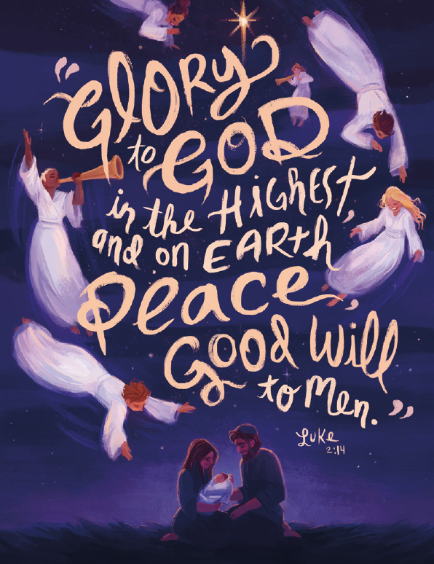
Glory to the Son!

