Once Jesus sat upon a hill
And taught a multitude
Of faith and love and peace and joy
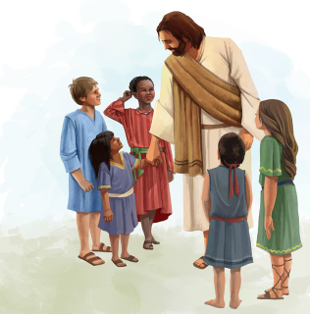
He taught them to do good
The scriptures bring these words to me
As though I had been there
And when I read them I can feel
My Savior’s tender care
Once Nephi, Alma, Samuel, John
Were prophets God had sent
They taught his children faith and hope
They taught them to repent

