The shepherds on the hillside
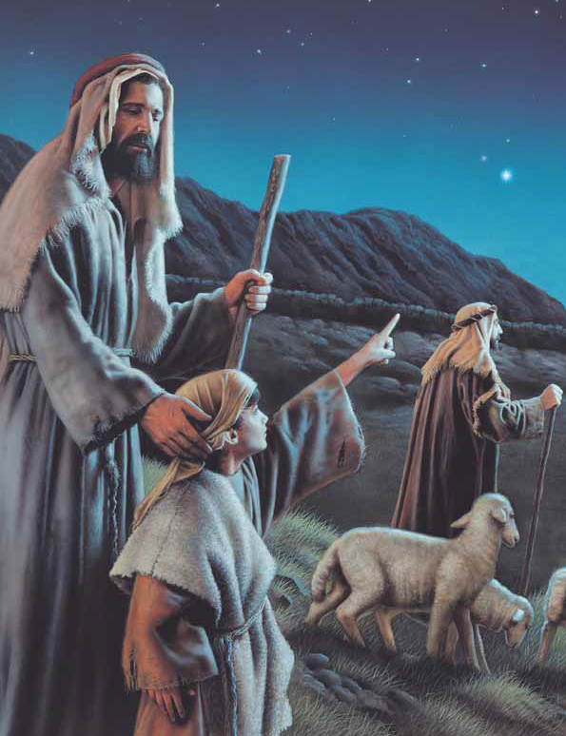
Caring for their flocks
They saw the Heavens grow bright
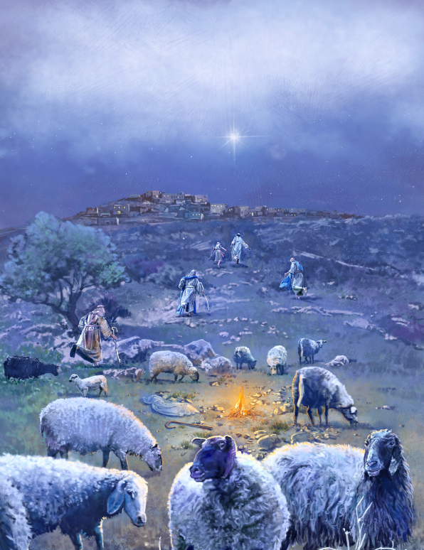
Light all around
Angels filled the sky
In a glorious sound

Alleluia, Alleluia, Alleluia
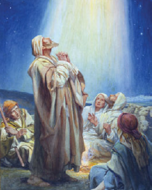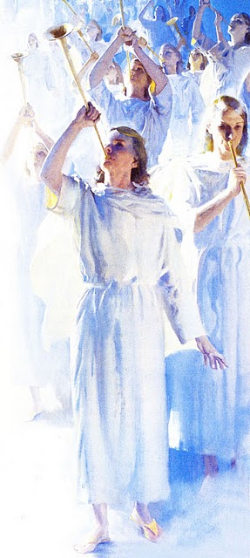
Angels did sing
The wise men on the hillside
Looking for Christ’s sign
They saw heavens grow bright
A new star bound
Angels filled the sky
In a glorious sound

Alleluia, Alleluia, Alleluia
Angels did sing

