An Angel to Watch Over Me

By Sally DeFord

Music at
www.defordmusic.com

She watched by my cradle through long
Sleepless nights
She taught me to pray
As she knelt by my side
She guarded my childhood
And all through the years
She echoed my laughter
She counted my tears
In the arms of my mother
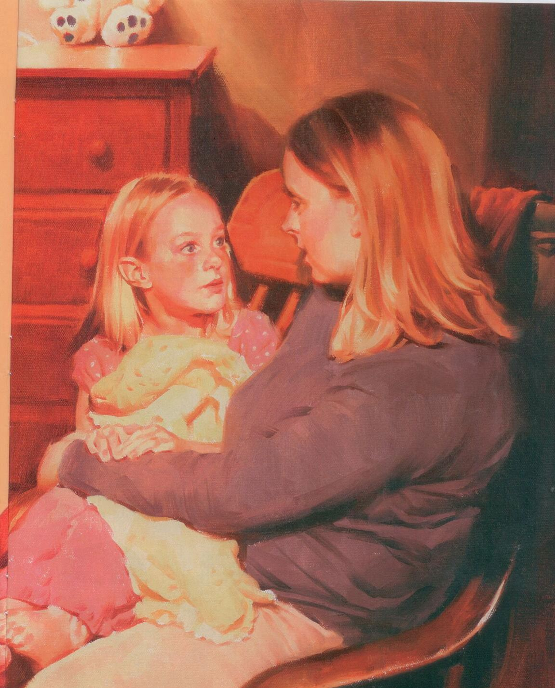
I came to believe
That God sent an angel
To watch over me
She taught me the meaning
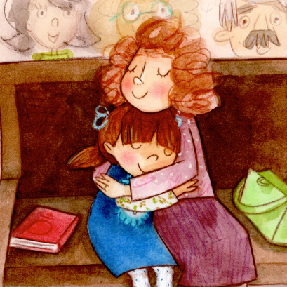
Of courage and faith
She taught me to live
With the Lord as my strength
She taught me to follow
The pathway He marked
She guided my steps
When the journey grew dark
And I know there were dangers
That I could not see
But God sent an angel
To watch over me
She taught me to serve
With a spirit that sings
She taught me to seek
After heavenly things
And because of her love
And her kindness and care
Because of the place
That I hold in her prayers
And because of her goodness
I still believe
That God sent an angel
To watch over me

