Oh, beautiful for spacious skies
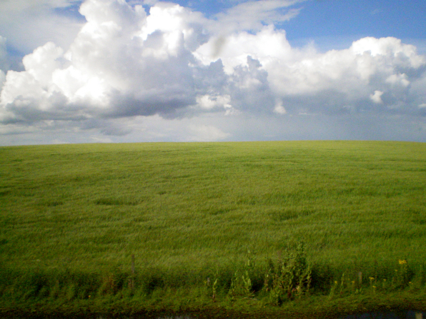
For amber waves of grain
For purple mountain majesties
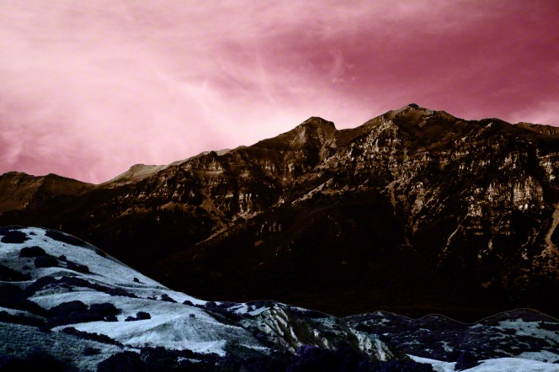
Above the fruited plain!
America! America!
God shed his grace on thee
And crown thy good with brotherhood
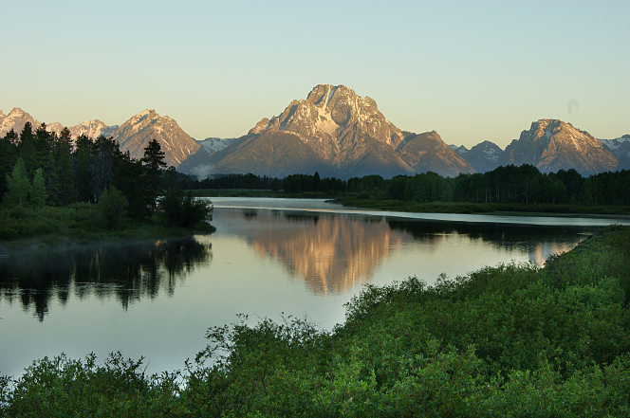
From sea to shining sea
Oh, beautiful for pilgrim feet
Whose stern, impassioned stress
A thoroughfare of freedom beat
Across the wilderness!
America! America!
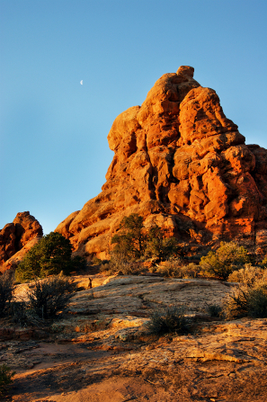
God mend thine ev’ry flaw
Confirm thy soul in self-control
Thy liberty in law

Oh, beautiful for heroes proved
In liberating strife
Who more than self their country loved
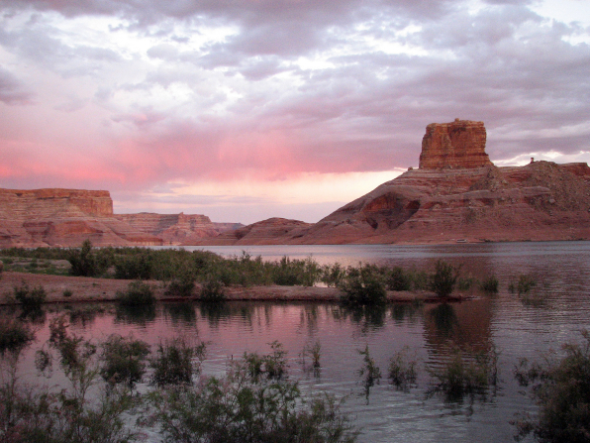
And mercy more than life!
America! America!
May God thy gold refine
Till all success be nobleness
And ev’ry gain divine
Oh, beautiful for patriot dream
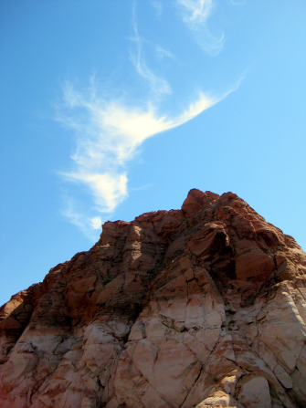
That sees beyond the years
Thine alabaster cities gleam
Undimmed by human tears!
America! America!
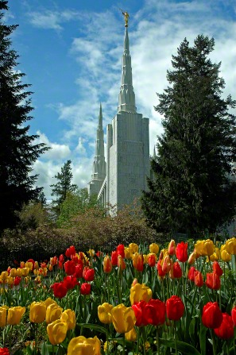
God shed his grace on thee
And crown thy good with brotherhood
From sea to shining sea

