All creatures of our God and king
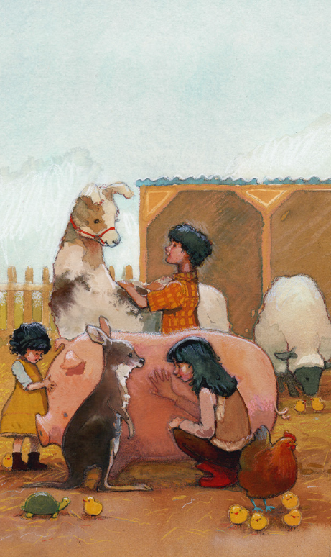
Lift up your voice and with us sing
Alleluia, Alleluia
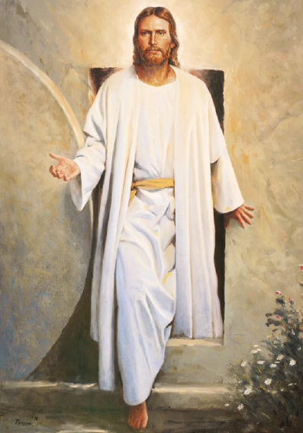
Thou burning with golden beam
Thou silver moon with softer gleam
Alleluia, Alleluia
Alleluia! Oh praise him! Alleluia!

Thou rushing wind that art so strong
Ye clouds that sail in heaven a long
Alleluia, alleluia
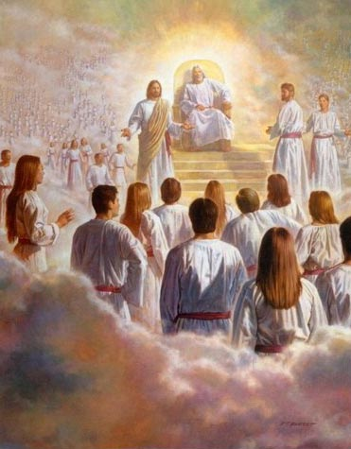
Thou rising morn in praise rejoice
Ye light of evening find a voice
Alleluia, Alleluia
Alleluia! Oh praise Him! Alleluia!
Thou flowing water pure and clear
Make music for thy Lord to hear
Alleluia, alleluia

Thou fire so masterful and bright
That gives to man both warmth and light
Alleluia, Alleluia,
Alleluia! Oh praise him! Alleluia!

