Each morning and evening
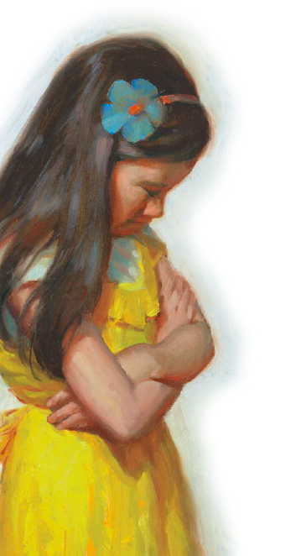
And ev’ry time I pray
I thank my Heav’nly Father
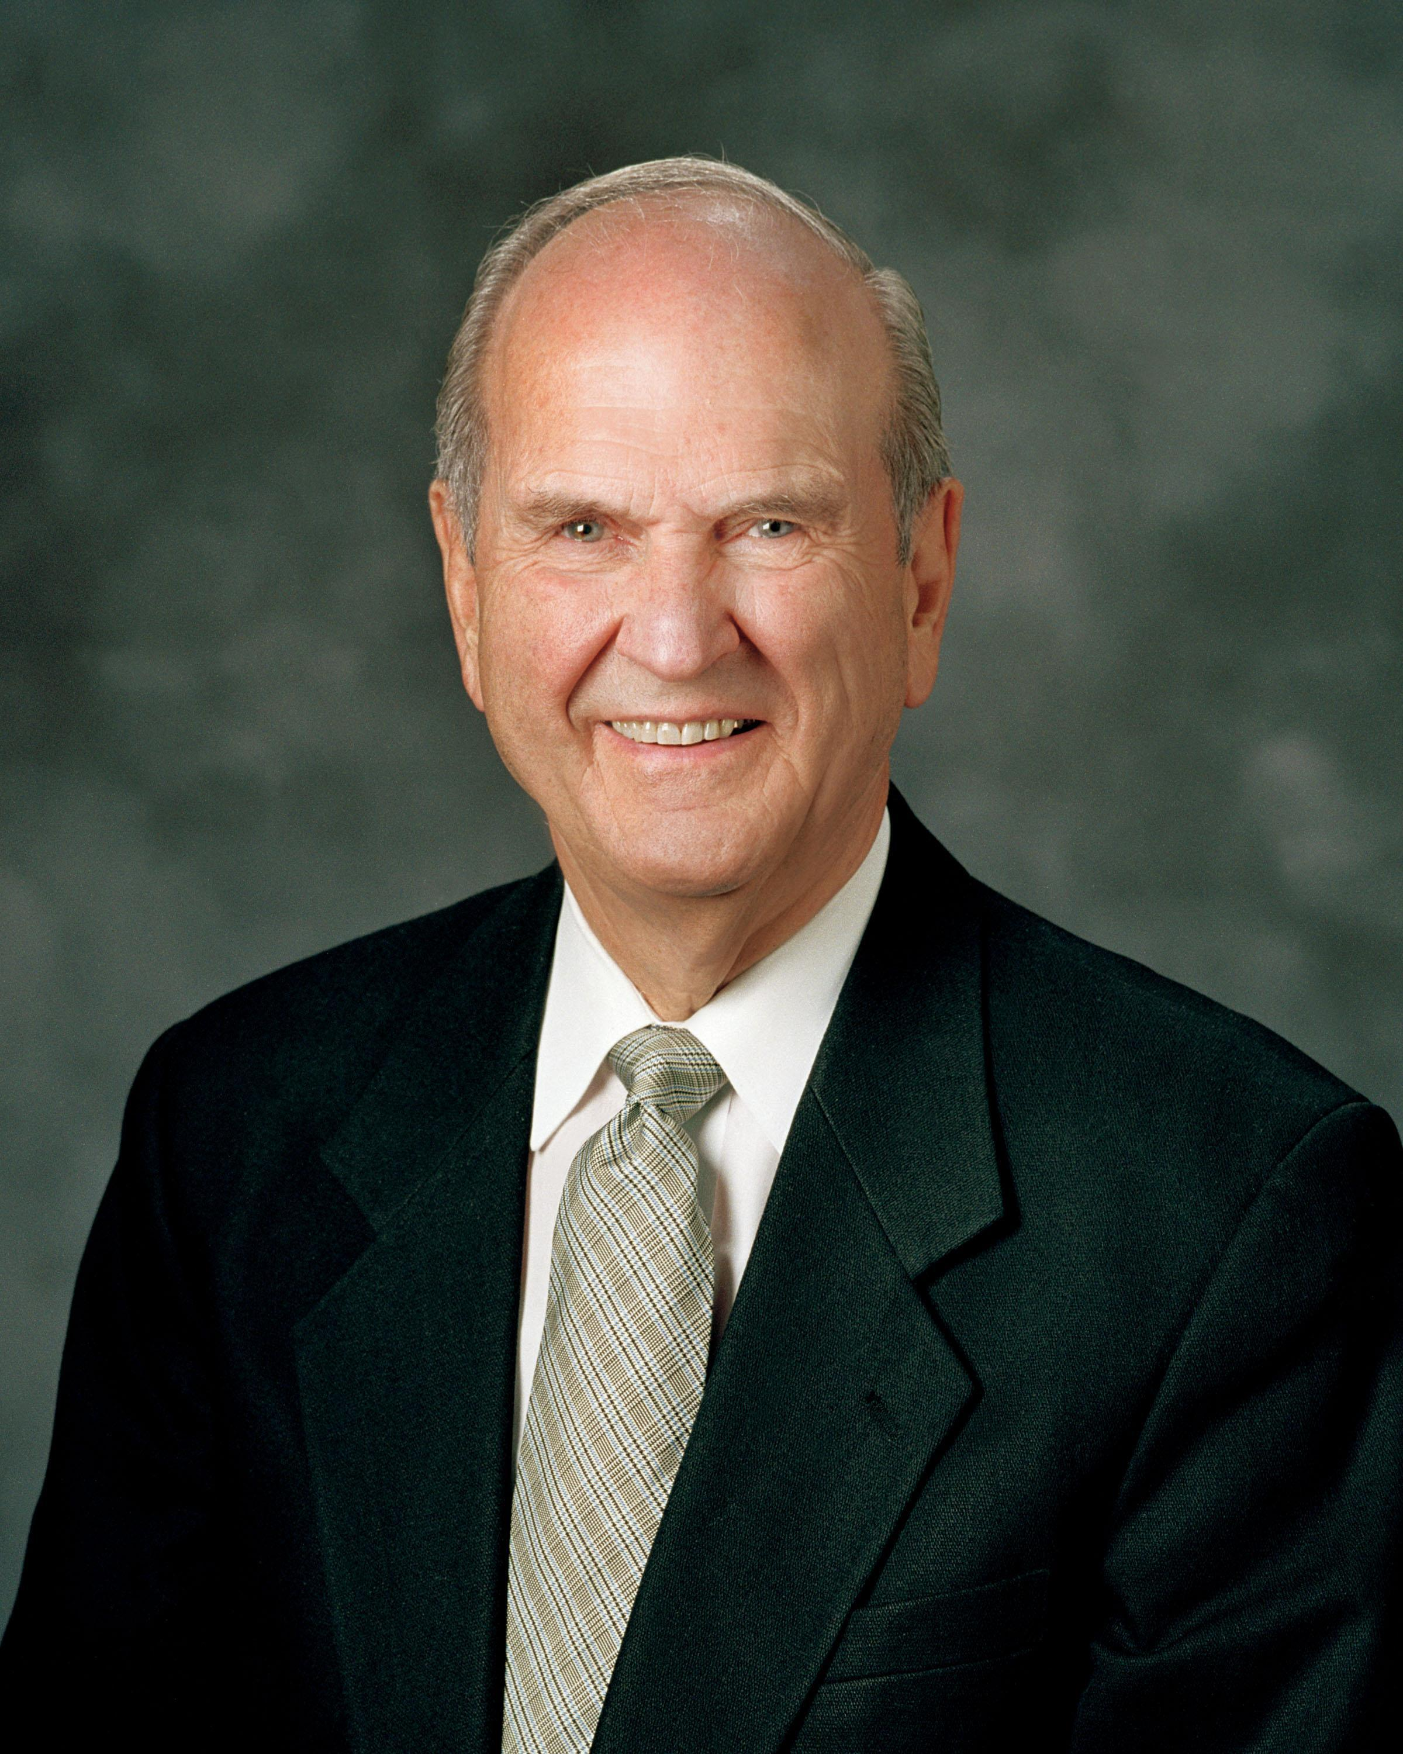
That a prophet lives today
A living link with heaven
So all the world can know
God loves us and leads us back
To our heav’nly home
A witness, he shows us
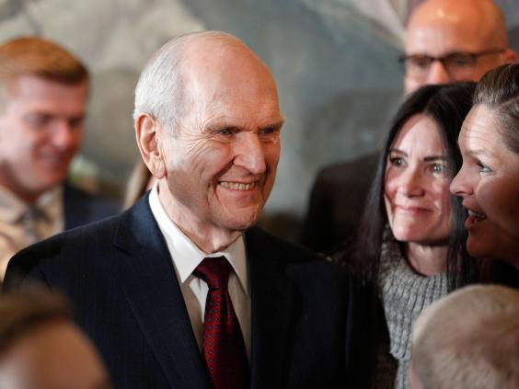
The strait and narrow way
I thank my Heav’nly Father
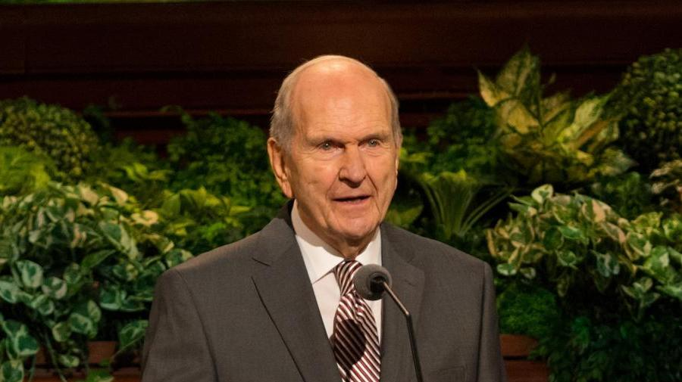
That a prophet lives today
He’ll always guide us truly

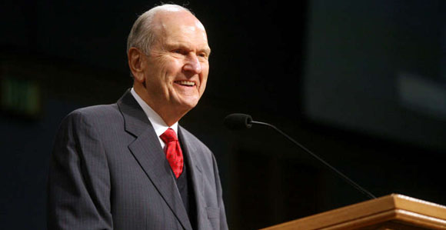

I’ll try to follow him

He loves us and leads us
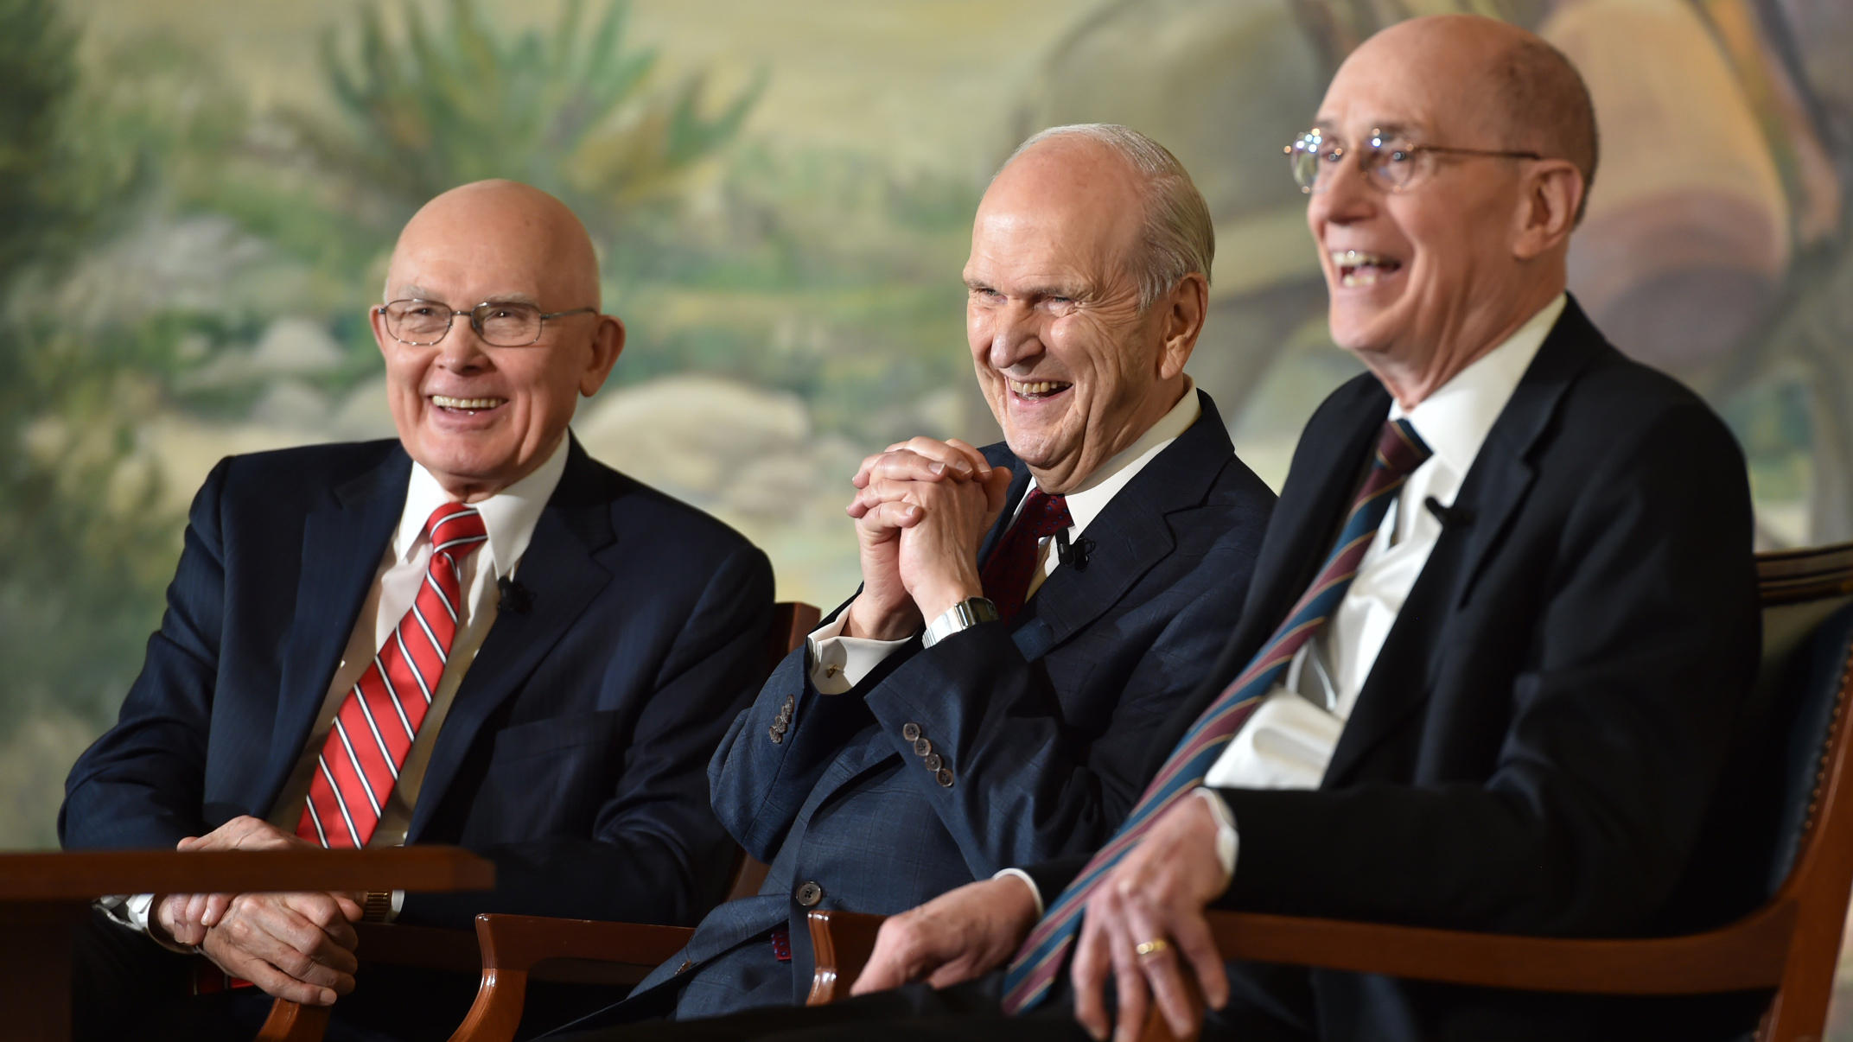
To live with God again

