Suffer the children to come unto me
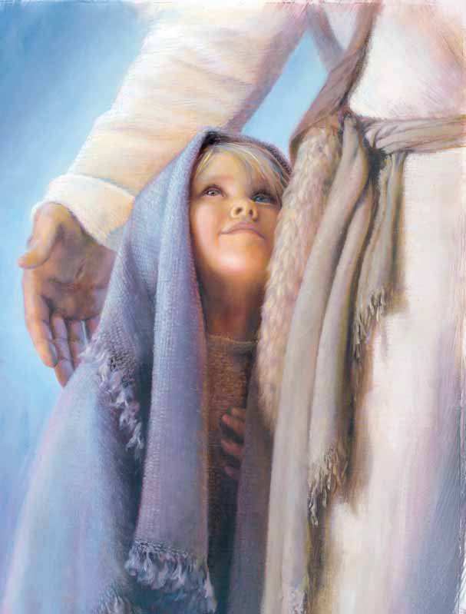
Jesus taught His disciples of old
Then He took every child
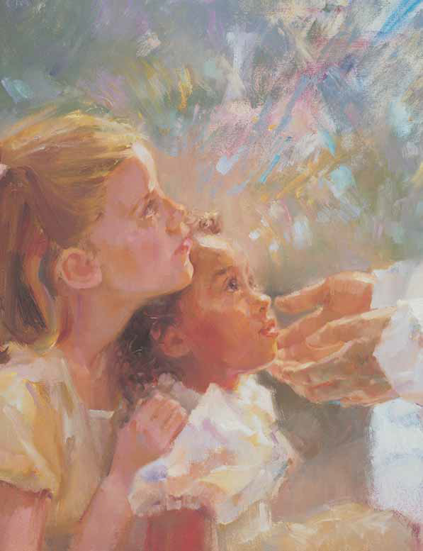
In His loving embrace
And He blessed them so long ago
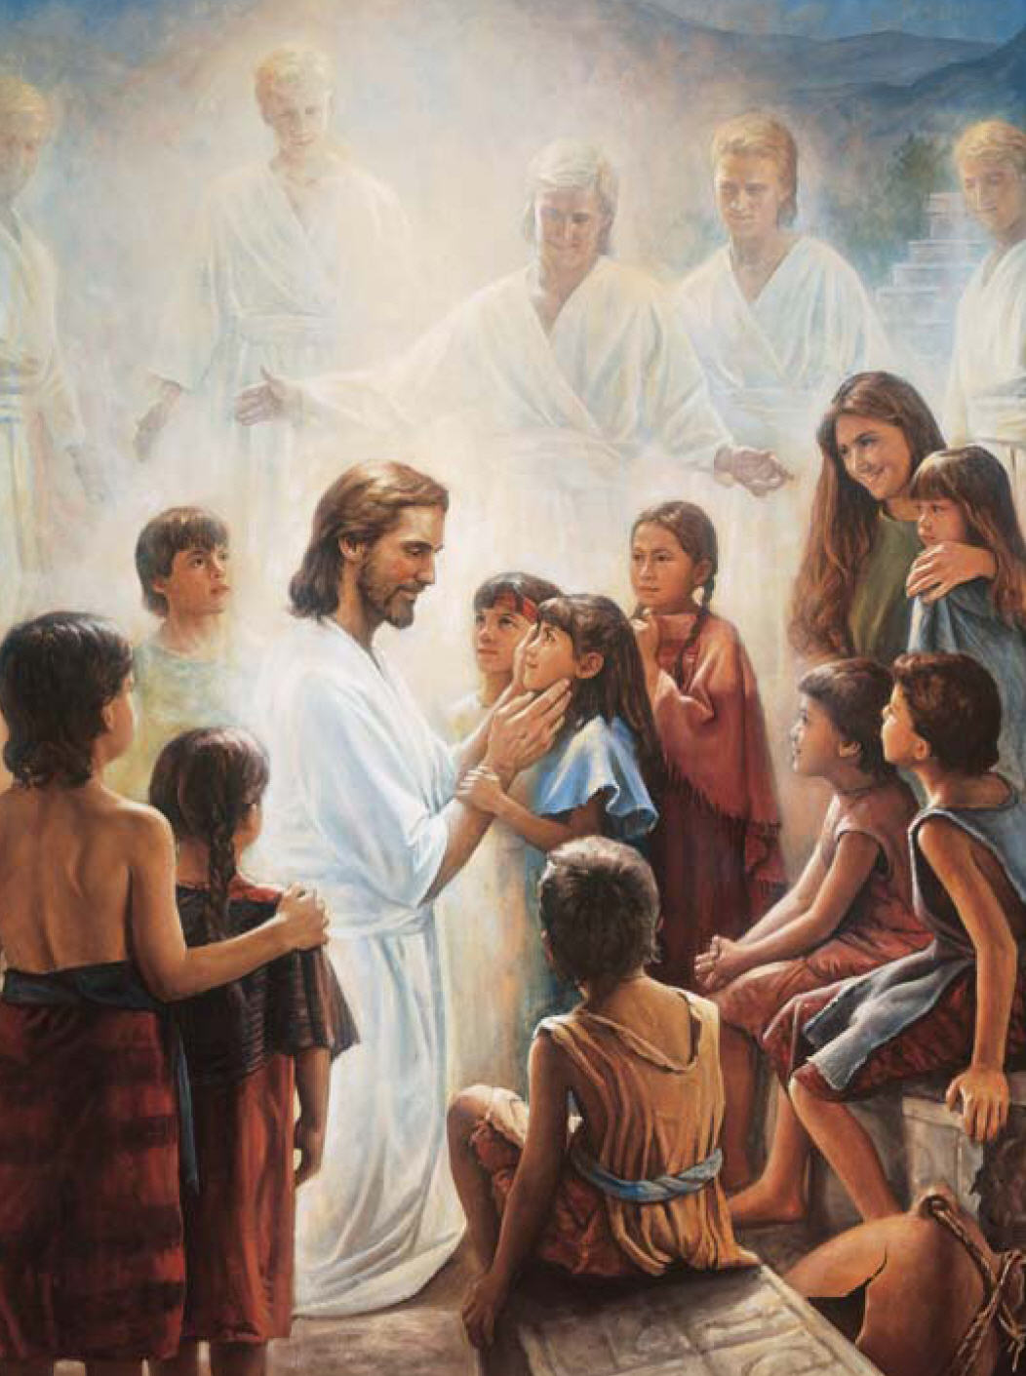
Bring me your little ones, Jesus said
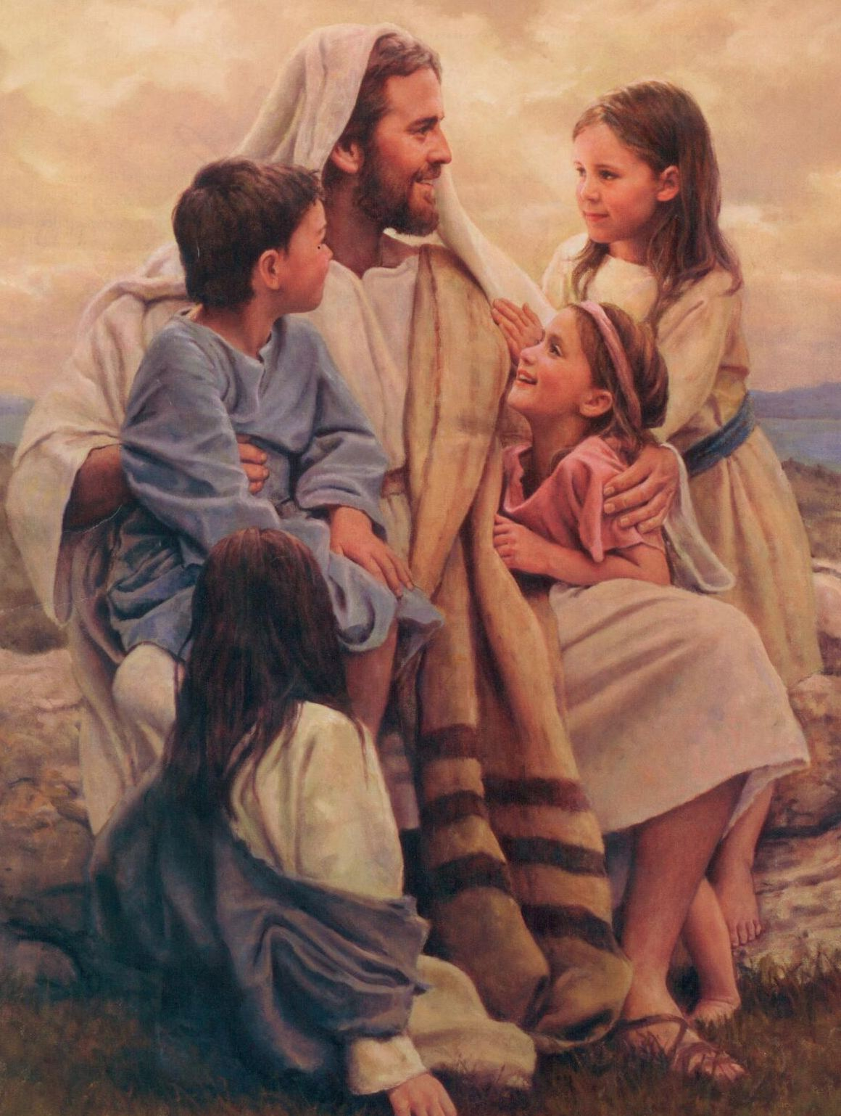
For of such shall my kingdom be
There was room in His arms
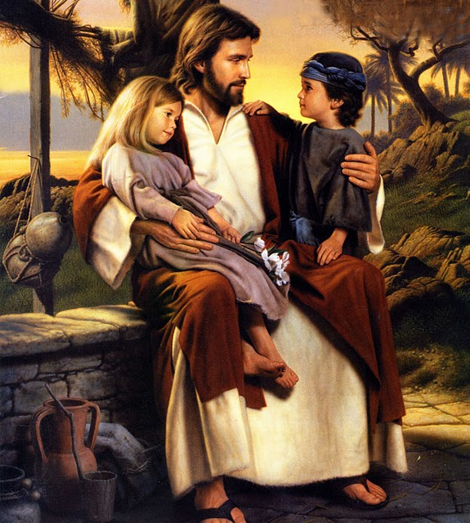
For His little ones then
There’s a place in His arms for me
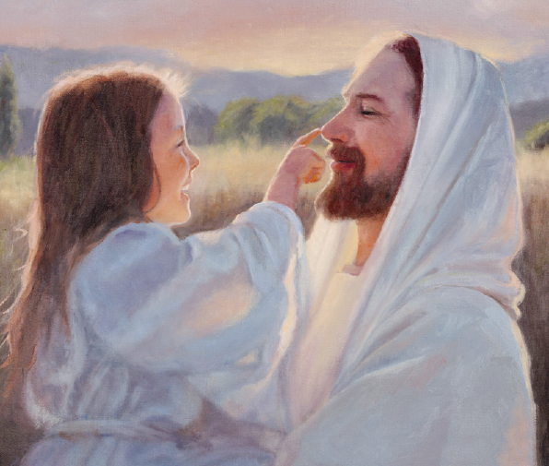

Oh, how the Savior
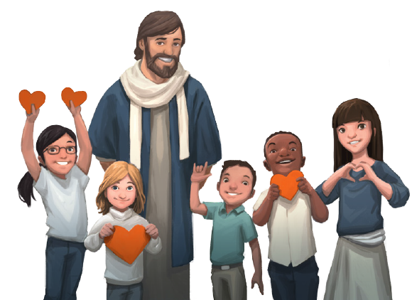
Loves each little child

How He smiles
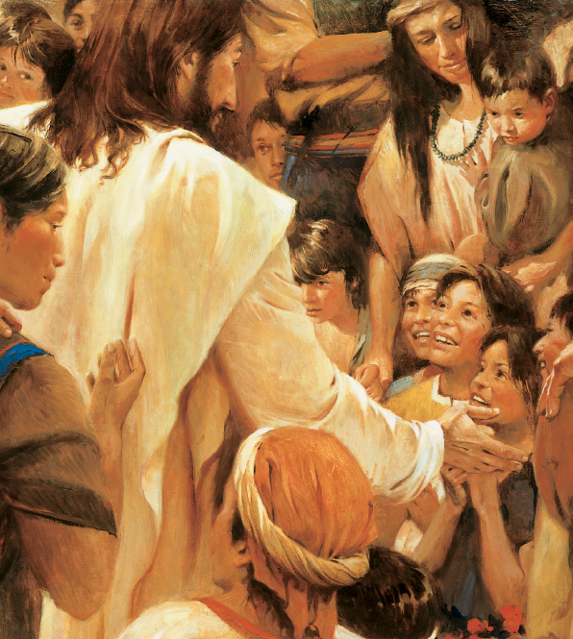
When I seek Him in faith
Then He gathers me close
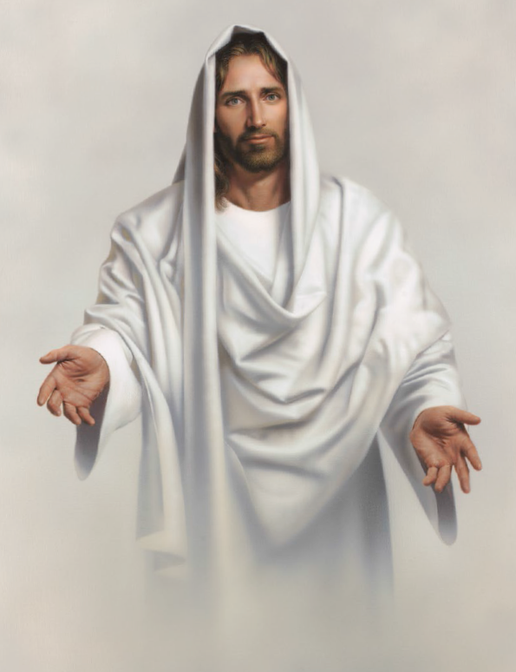
In His loving embrace
And He blesses me
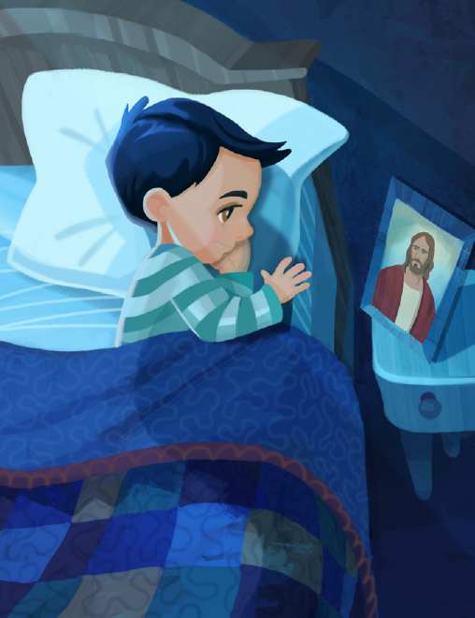
Day by day

