Heavenly Father, are you really there?
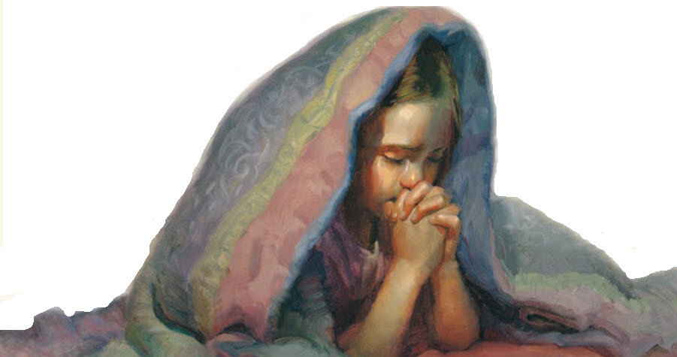
And do you hear and answer every child’s prayer?
Some say that Heaven is far away
But I feel it close around me as I pray
Heavenly Father I remember now
Something that Jesus told disciples long ago
“Suffer the children to come to me.”
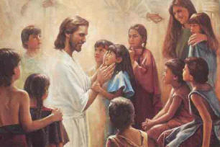
Father in prayer I’m coming now to thee
Pray, he is there
Speak, he is listening
You are his child
His love now surrounds you
He hears your prayer
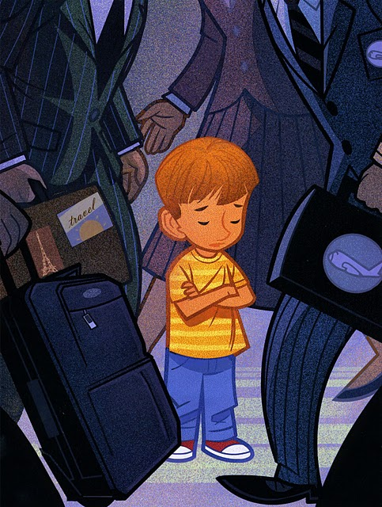
He loves
the children
Of Such is the kingdom
The kingdom of heav’n

