- I know that my Redeemer lives
- What comfort this sweet sentence gives!
- He lives, he lives, who once was dead
- He lives my ever living Head
- He lives to bless me with his love
- He lives to plead for me above
- He lives my hungry soul to feed
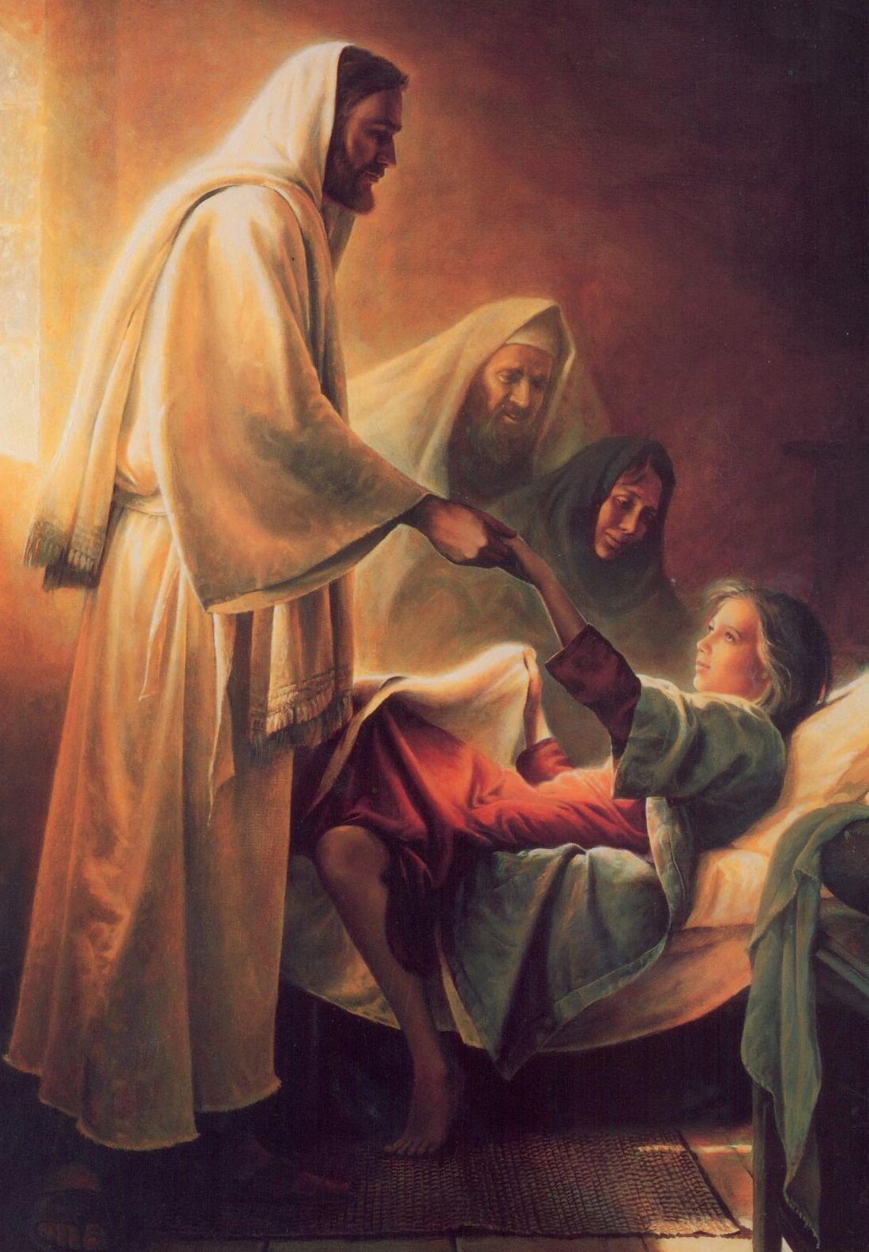
- He lives to bless in time of need
- Heavenly Father, are you really there?
- And do you hear and answer every child’s prayer?
- Some say that Heaven is far away
- But I feel it close around me as I pray
- Heavenly Father I remember now
- Something that Jesus told disciples long ago
- “Suffer the children to come to me.”
- Father in prayer I’m coming now to thee
- Pray, he is there
- Speak, he is listening
- You are my child
- His love now surrounds you
- He hears your prayer
- He loves
- the children
- Of Such is the kingdom
- The kingdom of heav’n

- He lives to bless me with his love
- He lives to plead for me above
- He lives my hungry soul to feed
- He lives to bless in time of need
Pray He is there!

