Blue skies, mountains, rainbows, fountains
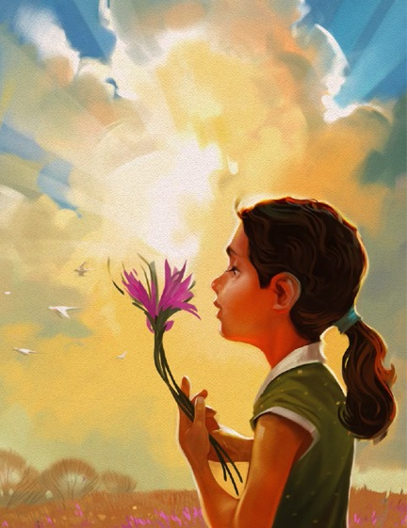
These are some things I love to see
Rivers, canyons, pine trees, oceans
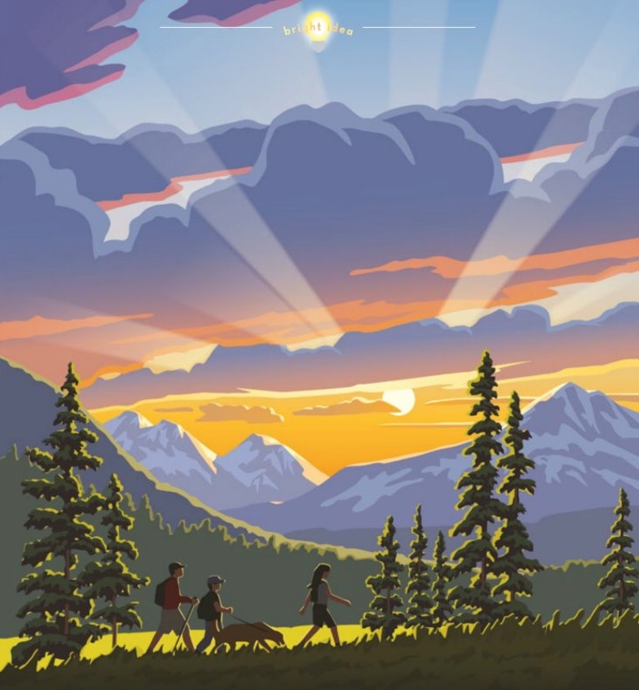
Heavenly Father made them for me
Life is o’er flowing
with beautiful things
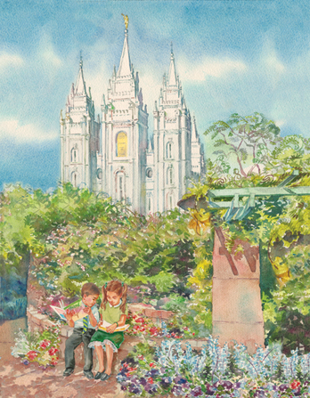
Made by our loving
and glorious King
If I but strive to be grateful and true
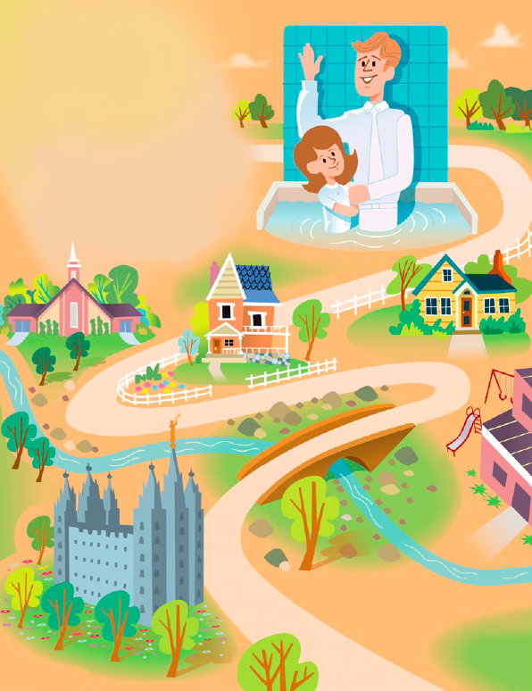
I can be happy in all that I do
Music, laughter, peace thereafter
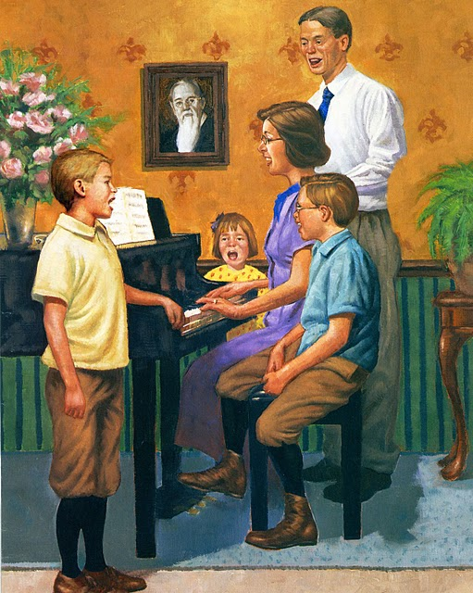
These are some things I love to hear
Please’s, thank-you’s, may I’s, can do’s
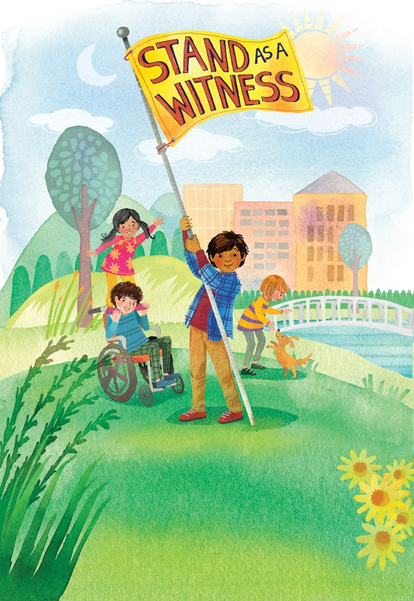
Hearing them fills my heart with good cheer
Silky flowers, cool rain showers
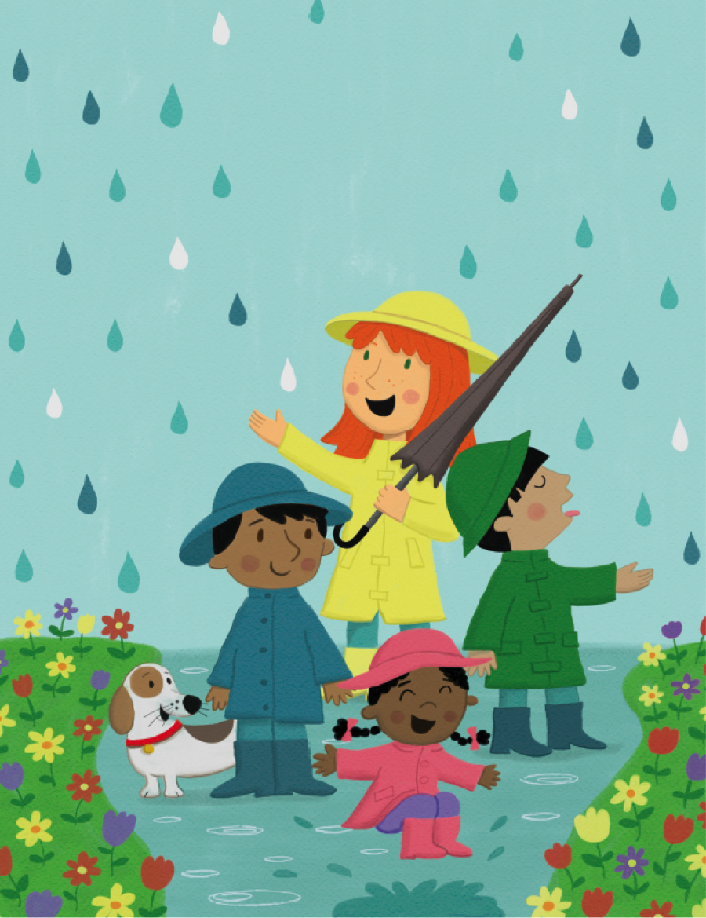
These are some things I love to feel
Promptings, guidance, warm assurance
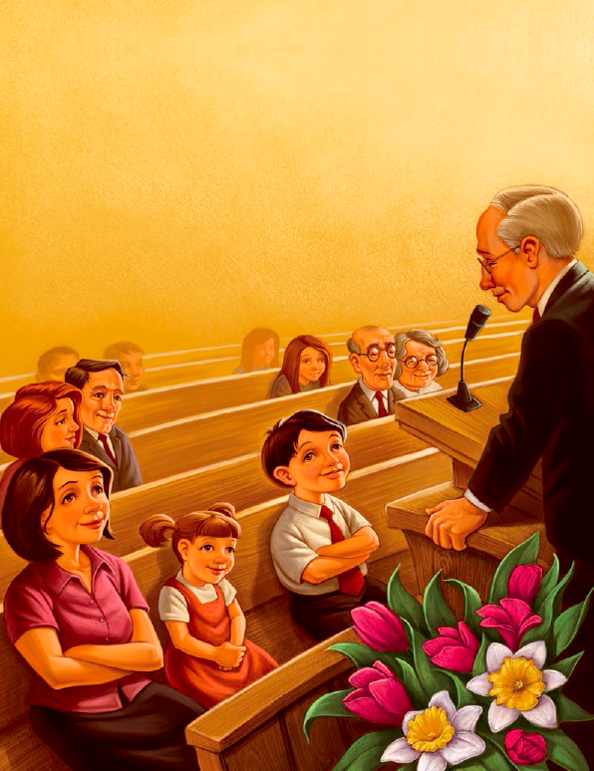
That’s how I know the Spirit is real

