Jesus is my shepherd
I’m His precious lamb
Tenderly He guides me
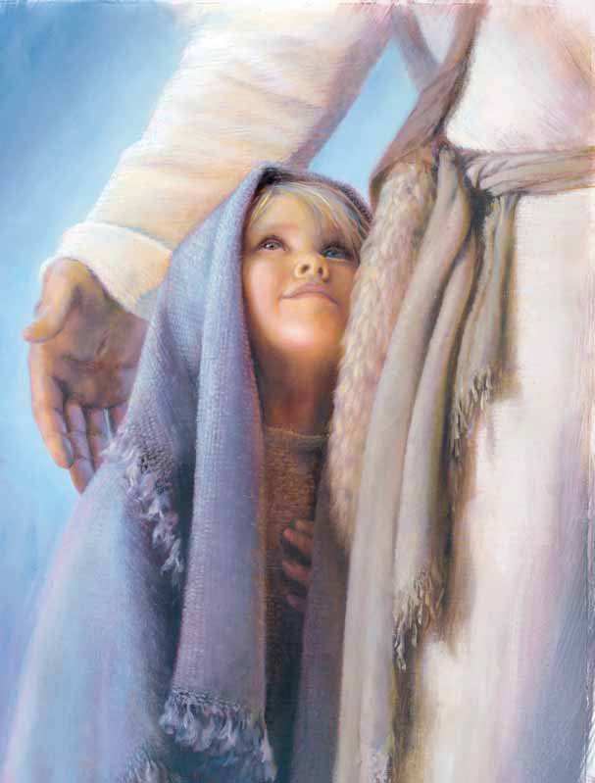
With his gentle hand
Calm are waters
where He leads
Green are pastures
where He feeds me
Jesus is my Shepherd
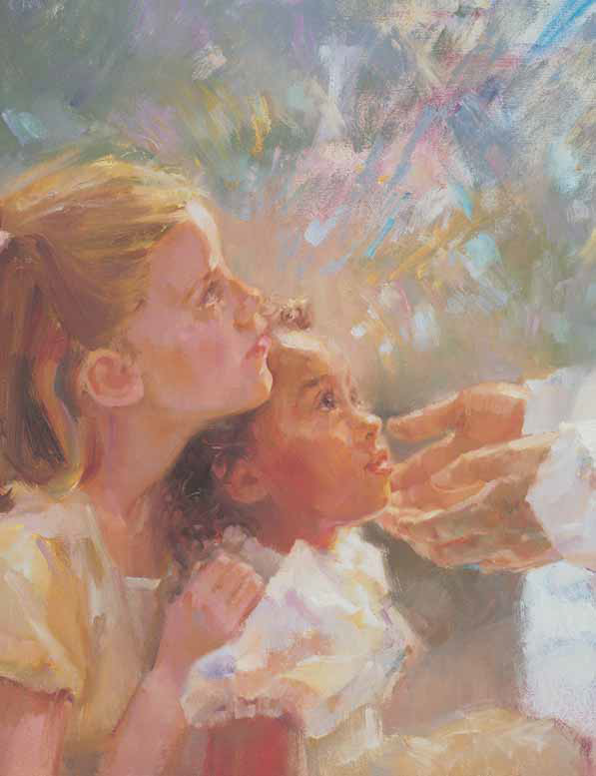
He loves me
Jesus is my Shepherd
Jesus knows my name
For His sheep are numbered
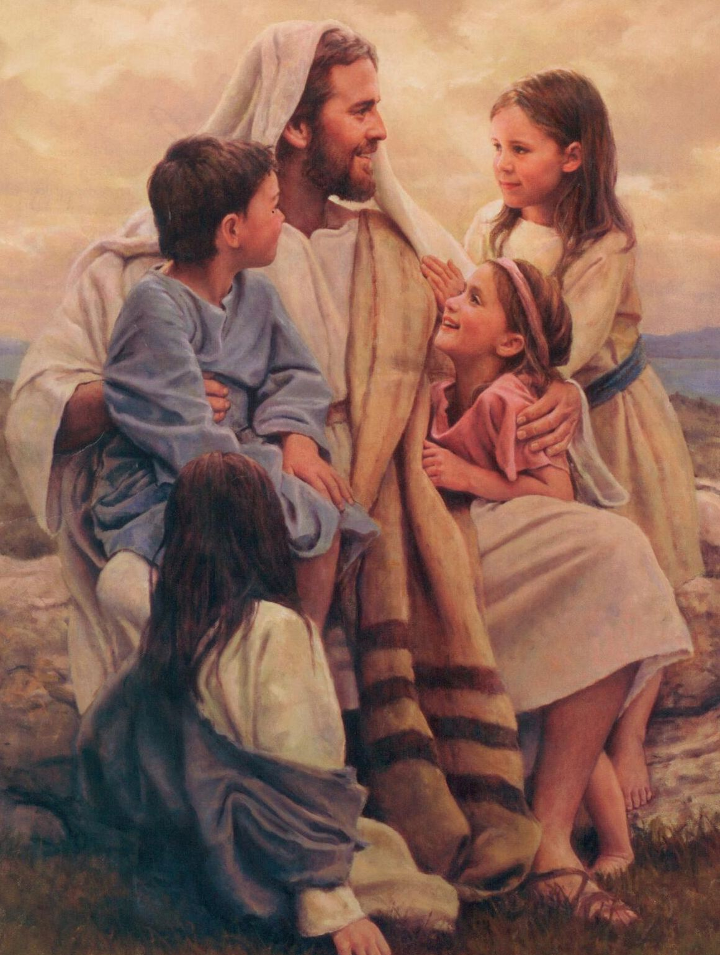
Each He loves the same
If my tiny feet should roam
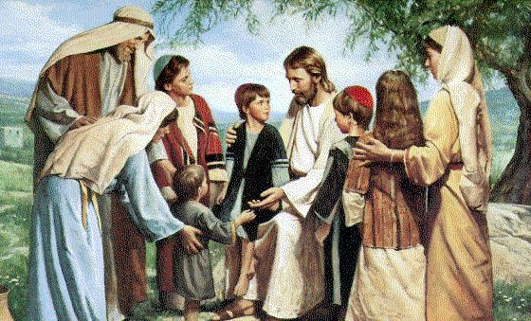
He would seek to bring me home
Jesus is my shepherd
He loves me
He loves me

