If I had been in Bethlehem
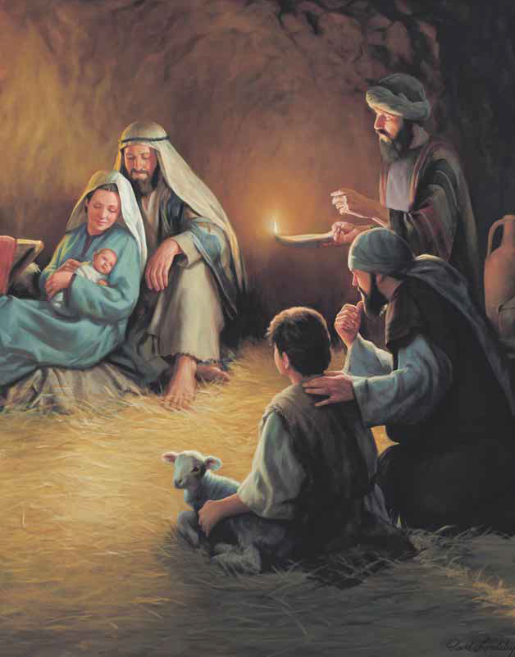
The night of Jesus’ birth
And heard afar the angels’ joyful song
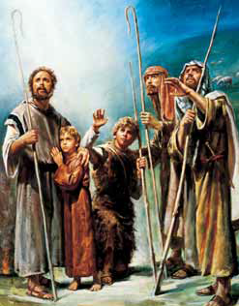
Of peace on earth
If I had seen the shepherds come
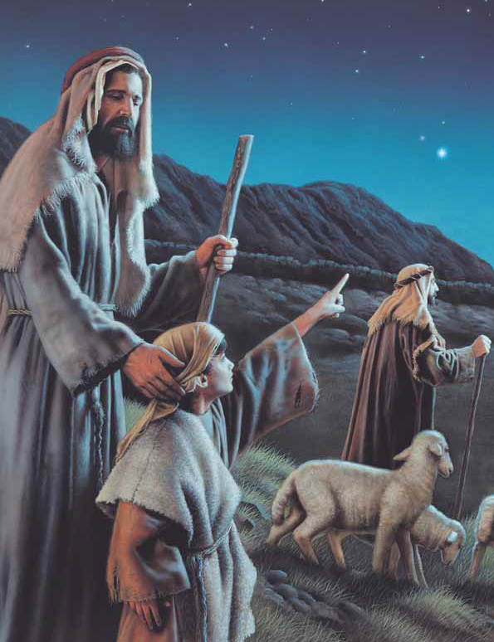
To seek the Baby fair
I think I would have followed them
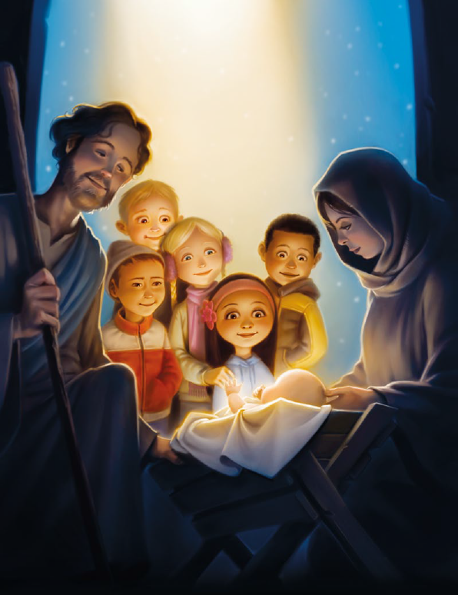
And knelt beside them there
If I had lived in eastern lands
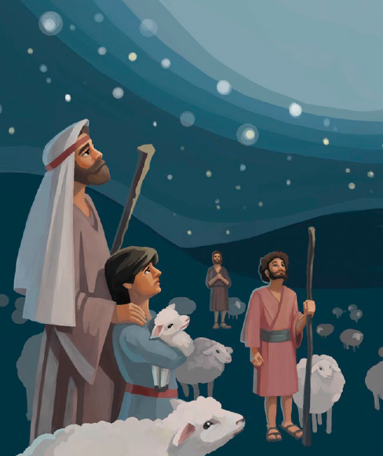
And watched with eager eyes
If I had seen His star appear
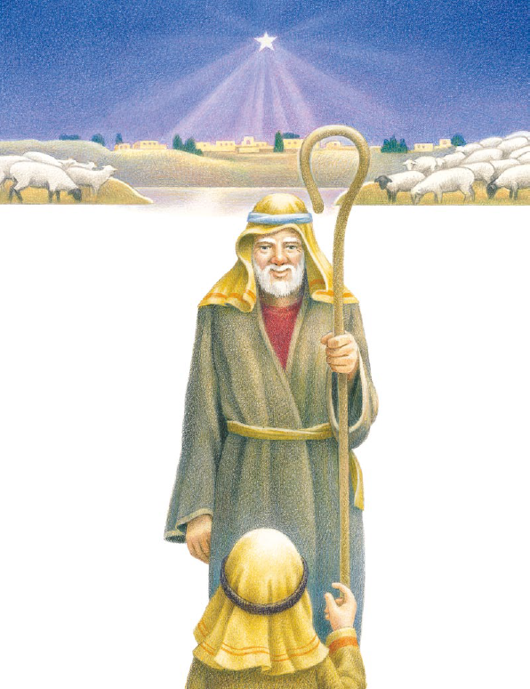
And blaze among the skies
If I had seen the wise men go
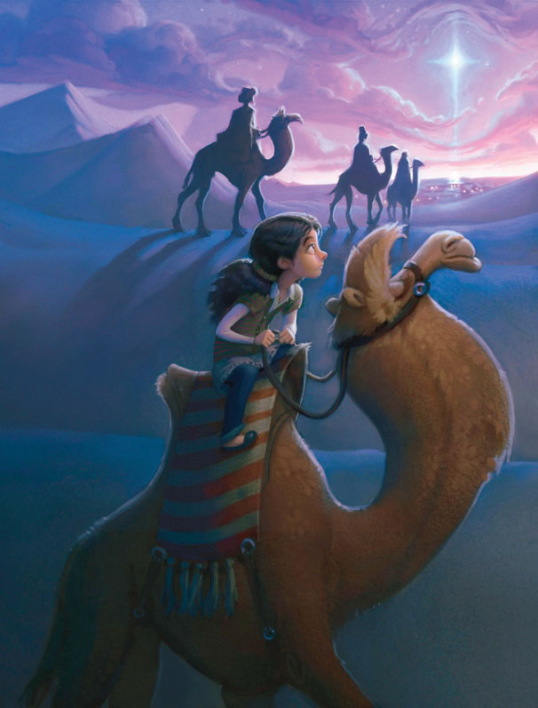
To seek the newborn King
I think I would have followed them
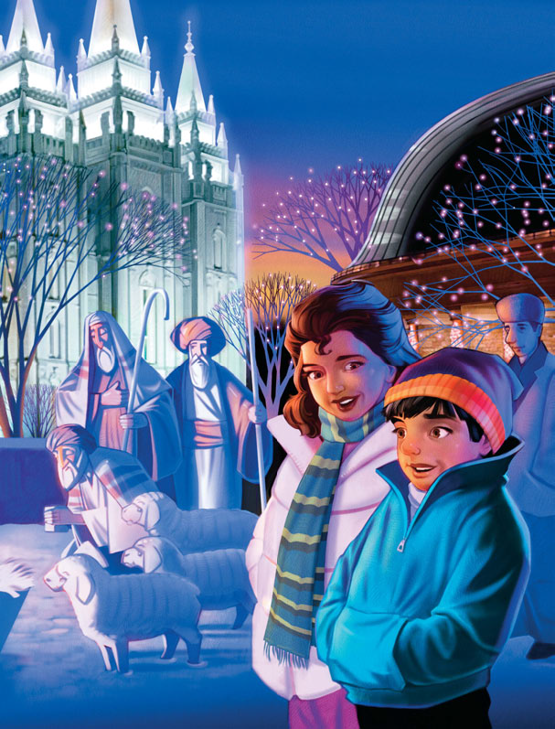
My finest gifts to bring
I did not live in Bethlehem
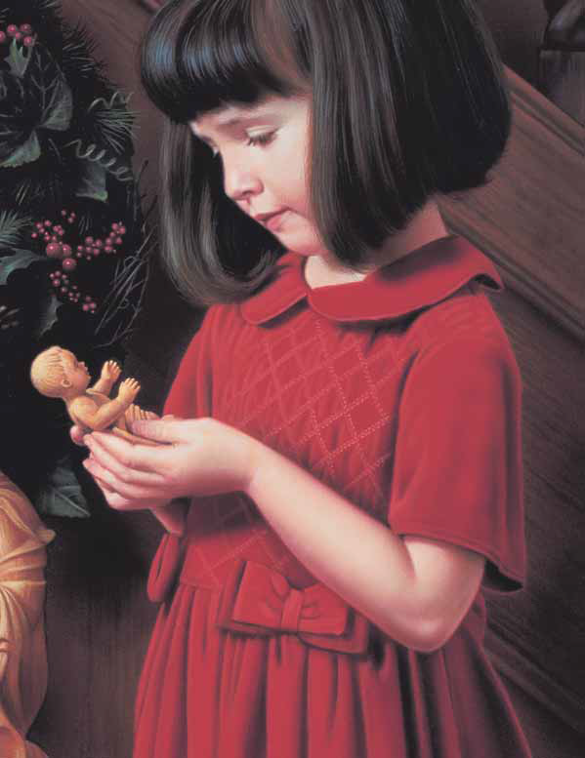
That Christmas night of old
Or travel with the wise men there
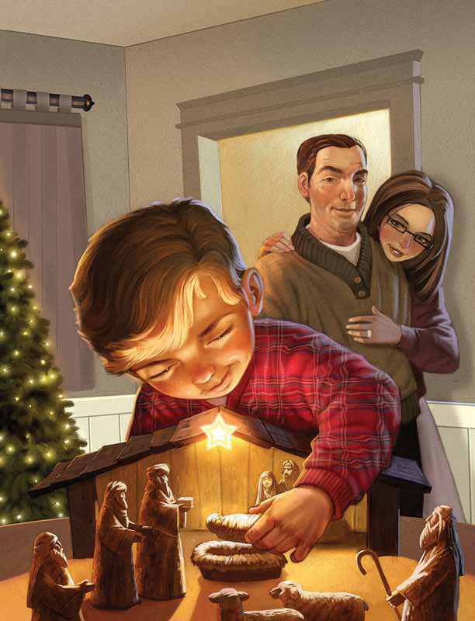
To bring Him gifts of gold
But I can bring a greater gift
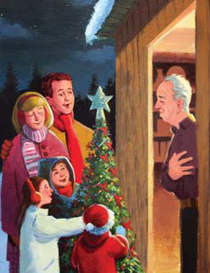
Than any earthly gem
For all my heart and all my love
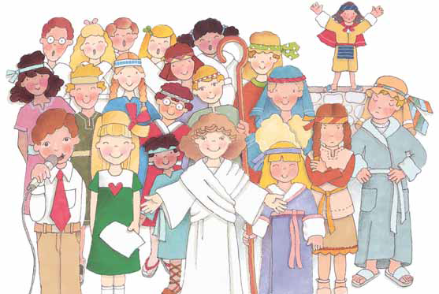
Will be my gift to Him

