I love to see the temple
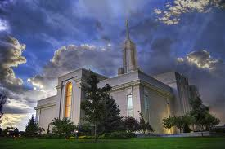
I’m going there someday
To feel the Holy Spirit

To Listen and to pray
For the temple is a house of God
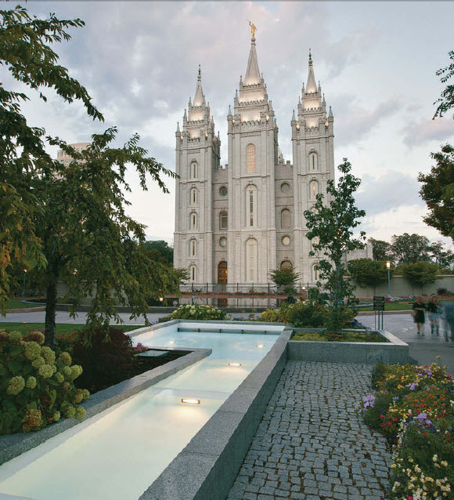
A place of love and beauty
I’ll prepare myself while I am young

This is my sacred duty
I love to see the temple

I’ll go inside someday
I’ll cov’nant with my Father

I’ll promise to obey
For the temple is a holy place
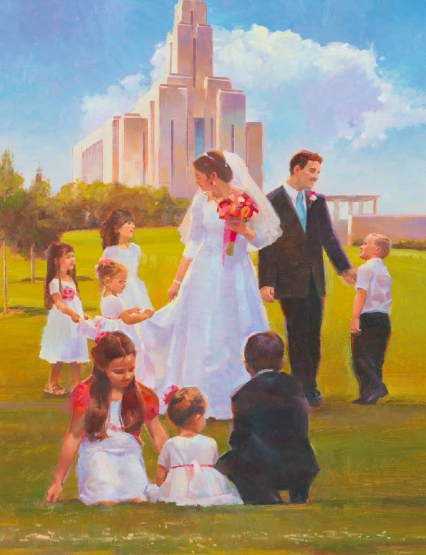
Where we are sealed together
As a child of God, I’ve learned this truth

A family is forever

