My life is a gift
My life has a plan
My life has a purpose
in heav’n it began

My choice was to come
to this lovely home on earth
And seek for God’s light
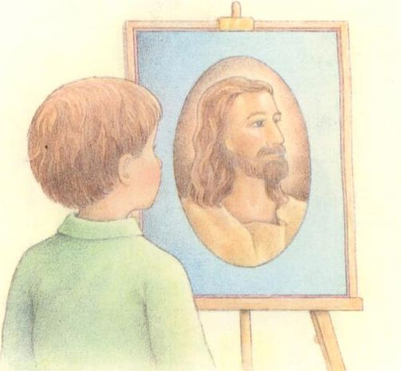
to direct me from birth
I will follow God’s plan for me
Holding fast to his work and his love
I will work, and I will pray
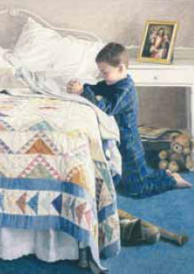
I will always walk in his way
Then I will be happy on earth
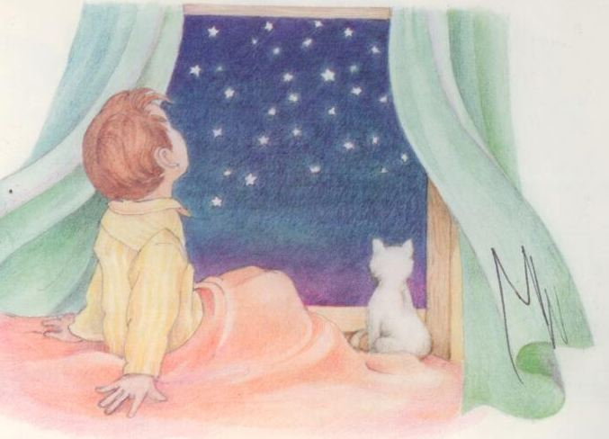
And in my home above

